VistARad software is used for high-volume interpretation of radiology and nuclear medicine images. VistARad is a component in the VistA Imaging system, and uses the VistA Imaging storage and acquisition infrastructure.
VistARad is integrated with the VistA Hospital Information System (HIS) in general and with the VistA Radiology package in particular.
Implementing VistARad allows a site to extend VistA Imaging into full PACS functionality at a low incremental cost. At sites using VistARad, the traditional HIS/PACS division is eliminated, resulting in improved efficiency and better radiology workflow.
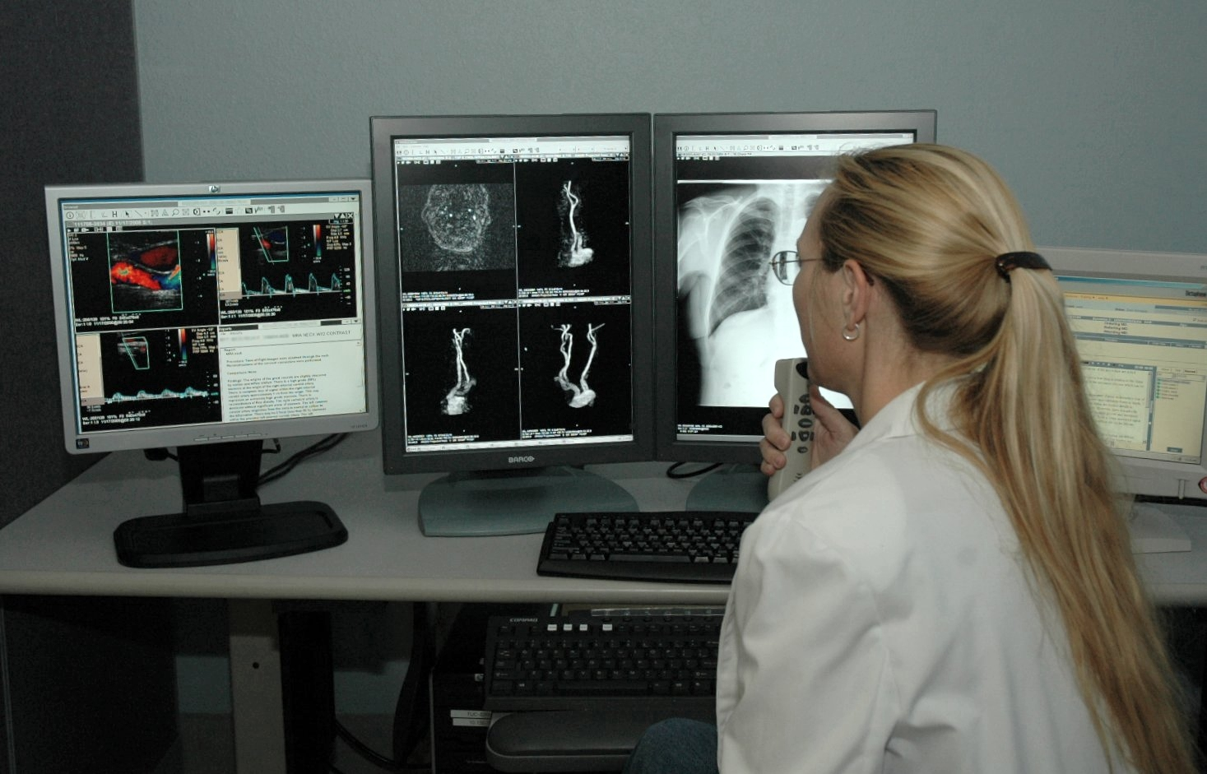
Jennifer Alcala, MD, reading at a VistARad diagnostic workstation
Photo courtesy of Abner Reese, Tucson VAMC

Key Features
- Highly customizable hanging protocols. |  | - Key image identification and saved annotations.
- Integration with TalkStation and PowerScribe voice dictation systems. |  | - User-specific profiles that are applied regardless of login location.
- Easy access to image review, analysis, and manipulation tools. |  | - Optional on-demand routing for telemedicine/teleradiology.
- A ‘ReadList’ function that allows a user to update the status of an open exam and immediately display the next unread exam in a single step.  - Site-configurable exam lists. |  | - Direct access to requisitions, reports, and health summary data.  - Compliant with HIPAA, the Federal Privacy Act, and VA security policies.

Detailed Information

Adaptable Exam Lists
Exam lists are available as a set of tabs in the Manager window. Users can reorder and show or hide exam list tabs.
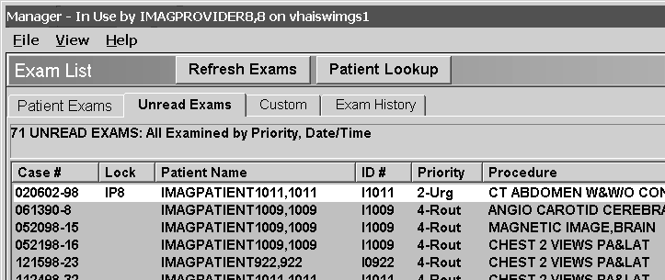
The following exam lists are available:
List | Description
Patient Exams | Lists all exams for each displayed and/or selected patient. Broken into sub-lists by patient.
Unread | Exams ready for interpretation.
Exam History | Exams viewed in the current session.
Recent | Interpreted exams awaiting report verification, can be displayed at the user’s option.
All Active | Combines the Recent and Unread lists, can be displayed at the user’s option.
Custom lists | Customizable by site. Typically, a subset of the Unread list.

Automatic Exam Prefetch and Prior Display
When VistARad’s prefetch function is used, a patient’s registration triggers the automatic retrieval of related prior exams from the archive (jukebox) to Image servers (the RAID). When a radiologist is ready to interpret an exam, related priors are available without delay. Prefetch can be customized on a site-by-site basis.
When hanging protocols are used, prior exams can be automatically displayed when a current exam is displayed.

Automatic Exam Locks
The first radiologist to open an unread exam will have the exam locked automatically in their name. Other users can display the exam, but only the person who locked the exam can update the exam’s status. If a radiologist elects to close the exam without interpreting it, the lock is removed and the exam can be locked and interpreted by a different radiologist.

ReadList
When the ReadList feature is used, the user can update the status of one exam and trigger the display of the next exam in a single step. Because the next exam has already been loaded in the background and is held in memory, the display of the next exam is immediate.

Integrated Patient Record Data
For any selected exam, a patient profile, a requisition, or a report from VistA can be displayed. Requisitions can be displayed automatically when an exam is opened.
Using the VistA Health Summary reporting capability, a radiologist can view other parts of a patient's medical record, such as laboratory and pathology information. Users can define a short list of preferred health summary reports and can also define a default report that can be opened in a single step.

Hanging Protocols
Hanging protocols can automate many of the repetitive tasks related to locating priors and arranging and adjusting images as they are loaded for display. Users can select from site-defined collections of hanging protocols or define their own personal hanging protocols.
- A hanging protocol can be automatically selected based on exam characteristics when an exam is opened, or can it be manually selected by a user before opening an exam.
- When a hanging protocol is applied, the images are automatically grouped into one or more viewports (see next section) based on the hanging protocol definition and the attributes (modality type, series, body region descriptors, etc.) of the images. Within each viewport, the hanging protocol sets the layout (stacked or tiled) and image display properties such as scale, window/level, etc..
- Along with performing standard image processing, hanging protocols can automatically split interleaved series (based on data in the DICOM header), and can use variable window/level settings provided by the acquisition modality (for proper handling of MR images).

Flexible Viewports for Image Display
Viewports are the basic unit of display space in VistARad, and are used in both the Viewer and Browser window.
The illustration below is an example of two exams (a current and a prior) displayed in the Viewer window.
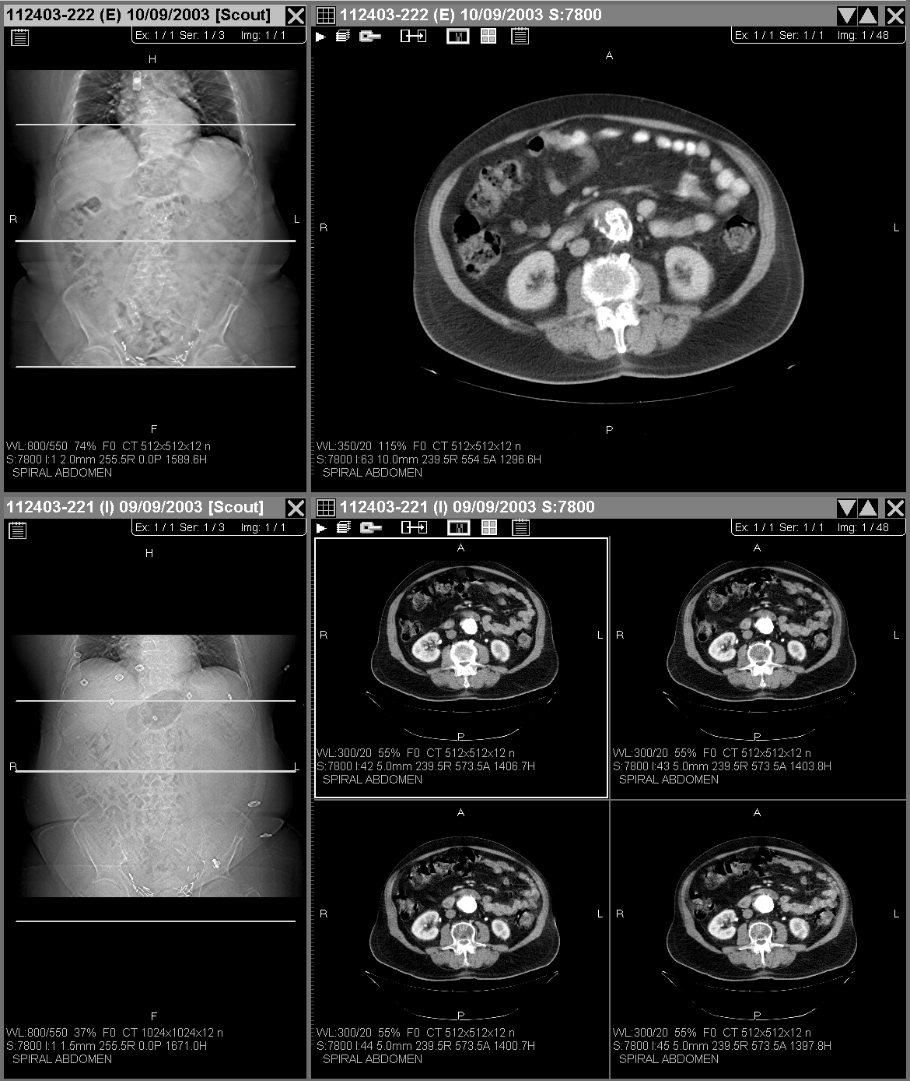
The viewports on the left contain one image each
(a scout).

The viewports on the right contain one series each.

 This series is displayed in stacked mode.
 This series is displayed in tiled mode.
In the Viewer window, the size and number of viewports is determined by the active hanging protocol. Depending on the type of exam being displayed and on the hanging protocol being used, viewports can be automatically loaded with a single image, a series or sequence, or an entire exam. Multiple prior exams can also be automatically loaded into a viewport if a hanging protocol is used. A simple integrated control allows easy navigation between different series or exams within a viewport
In the Browser window, the size and number viewports is flexible, and can be changed as needed. Viewports in the Browser contain a single group of related images. An exam can be quickly loaded into the Browser window on-demand.

Image Review & Manipulation Tools
All standard image manipulation tools (window/level, scale/zoom, sharpen, invert, reorient, and pan) are available. The following tools are also present:
Tool | Description
Full Screen | Temporarily expand a viewport to occupy an entire screen. Images in the viewport can be adjusted while in this view.
Magnifying glass | Create a movable area that can be manipulated independently from the rest of the image, or that can be used to mask the rest of the image.
Presets | Apply a predefined window/level setting (and other display properties) to a group of images. Users can create their own presets or use presets that are part of a group collection. Presets can be included in hanging protocol definitions.
Cine | Create a “flipbook” by displaying each image in a group in rapid succession. Users can set cine direction, link running cines, and manipulate images while the cine tool is running.
Link | Create a link between two or more groups of images. Sub-sequent changes made will apply to all linked images. Users can choose which properties are linked and which are not.
Copy Property | Copy window/level, scale, sharpen/smooth, relative position (pan), or orientation from one group of images to another.
Move | Reposition a group of images to a different viewport.
Clone | Create a duplicate of an existing group of images. The new group can be manipulated independently of the original group.
Split | Divide an existing group of images into separate groups. Associations with any scout images are retained.

Savable Annotation and Measurement Markup
Users can add annotations and measurements to displayed images.
- Annotation shapes and measurements are automatically saved with the exam if the exam is locked. Image presentation (W/L, scale, etc) is saved as well.
- Saved annotations are not ‘burned in’; they are saved separately in a supplemental file. A user displaying an annotated image can show or hide the annotations as desired.
- A future Imaging patch will allow images annotated in VistARad to be viewed using VistA Imaging’s Clinical Display software.
The following annotation and measurement tools are available:
Tool | Description
Text label | Create a text box and label image features.
Measure angle | Create two lines to calculate angles.
Measure Line/Area | Display measurement length or area for line or rectangle.
Hounsfield area | Designate a rectangular area within a CT image to view Hounsfield unit average, range, and standard deviation.
Auto-number | Number image features using numbering style (numeric, alphabetic, and spinal) of the user’s choice.
Line, rectangle, or ellipse | Draw straight lines, rectangles, or ellipses.

Key Images
Users can mark images as key (clinically significant) images. Key images, including their presentation state and any annotations added by the user, can be viewed separately from other images in the exam.
- Designating a key image does not alter the original diagnostic image. When a key image is designated, VistARad saves an identifier for the image and presentation state information in a supplementary file.
- Key images are marked by the physician during the interpretation process. Once an exam’s status has been updated in VistARad, key images cannot be added, removed, or altered.
- A future Imaging patch will allow key images to be identified and viewed using VistA Imaging’s Clinical Display software.

Scout (Localizer) Management
Scout images are loaded into a separate window that can be used or hidden as needed. Scout images can also be loaded into the main Viewer automatically via a hanging protocol. Scout-based navigation updates all appropriate images. If scout images are not present in an exam with images on intersecting planes, scouts can be generated by the user.

Teleradiology and On-Demand Routing
VistA Imaging’s routing feature can be used to improve turnaround times in exam interpretation and consultation. Sites that have implemented routing can automatically transmit exams to a remote VistARad workstation over a WAN. Automatic routing of priors and routing using lossless compression is also available. VistARad users at sites that use routing can also send images on an on-demand basis to remote VistARad workstations.
With routing, an off-site radiologist can interpret working from immediately available local copies of images, rather than having to retrieve the exams from across the network. When an off-side radiologist is reading remotely, VistARad can automatically filter exam lists to show only appropriate exams.

New feature in upcoming version (p18).
New feature in upcoming version (p18).
New feature in upcoming version (p18).
New feature in upcoming version (p18).
New feature in upcoming version (p18).
New feature in upcoming version (p18).

